EXPERIMENT 2
Design a UI where users recall visual elements (e.g., icons or text chunks). Evaluate the effectof chunkingonusermemory.
Roll no: 240701238 Name: Kathir Vikaas S

Frame 1: Instruction Page
- Purpose: Introduces the task and explains what users need to do.

Design Strengths:
  - Instructions are broken into short, numbered steps (chunking).
  - Clear title (“INSTRUCTIONS”) and simple language make it easy to follow.
  - Visual cues (back arrow, red header) guide attention.
- Effect on Memory: Chunking reduces cognitive load, helping users quickly grasp the rules before starting.

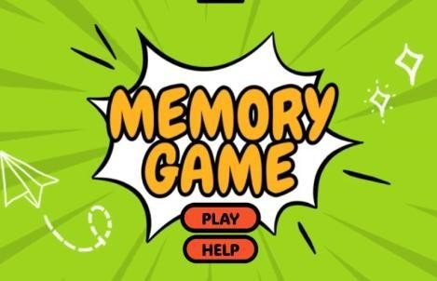
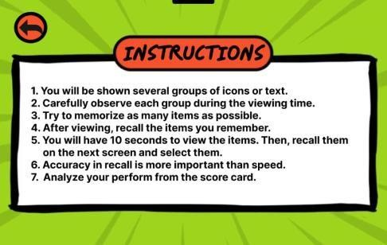

Frame 2: Chunking Phase
- Purpose: Displays a set of icons for users to memorize within limited time.

Design Strengths:
  - Countdown timer and progress bar create urgency and focus.
  - Icons are arranged in a grid, allowing grouping by category, color, or similarity.
  - Mascot (bee character) adds engagement and reduces stress.
- Effect on Memory: Encourages users to form meaningful chunks (e.g., animals vs. food), improving recall accuracy.

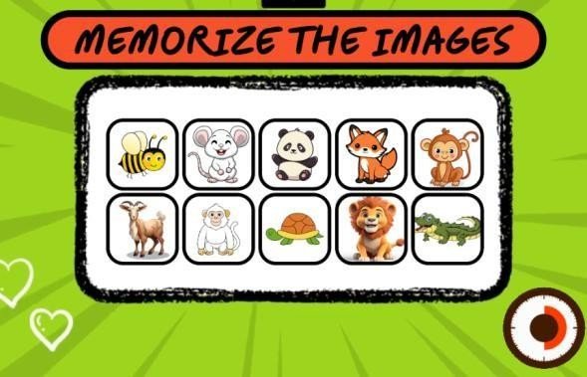

Frame 3: Recall Phase
- Purpose: Tests memory by asking users to select the icons they remember.

Design Strengths:
  - Clear instructions (“SELECT THE ITEMS YOU REMEMBER”).
  - Grid of icons includes both correct items and distractors, testing accuracy.
  - Simple selection buttons and a “SUBMIT” option make interaction straightforward.
  - Mascot continues to provide a playful, guiding presence.
- Effect on Memory: Reinforces recall by requiring discrimination between remembered and new items.
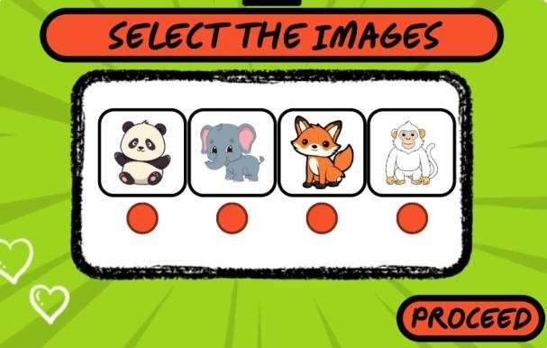

Frame 4: Result Page
- Purpose: Provides feedback on performance after the recall task.

Design Strengths:
  - Score is displayed clearly (e.g., “0–3”).
  - Title and feedback message (“THANKS FOR PLAYING!!”) make the result engaging.
  - Visual elements (star icon, bright colors) keep the tone positive.
- Effect on Memory: Immediate feedback helps users evaluate their recall ability and motivates improvement.

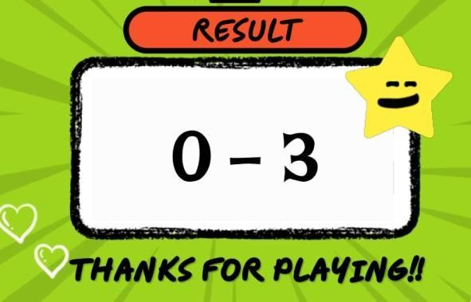

prototype Link : https://www.figma.com/proto/yiUrvAXiU6aCXXMU3yHTby/Untitled?t=LTMlmMuKEdXvoKse-1

